St. Bridget Catholic Church
2025-2026 Middle School Religious Education Calendar
Formation for all students in 6th through 8th grade takes place in the Saint Bridget Middle School building, from 10:30 AM – 12:00 PM.
For questions regarding Religious Education/Youth Ministry for 6th – 12th grade, including Confirmation Preparation, please contact Patrick Stearman at pstearman@saintbirdgetchurch.org or 804-525-9382, ext. 334.

August
17th – Parent + Youth Orientations
24th – Session 1
30th – No Class
September
7th – Session 2
14th – Ministry Fair and Parish Picnic
21st – Session 4
25th – Cardboard Box City Event
October
5th – Session 6
12th – No Class
19th – Session 7
26th – Session 8
November
2nd – No Class
9th – Session 9
16th – Session 10

23rd – Session 11
30th – No Class
December
7th – Session 12
9th – Session 13
16th – Session 14
21st – Session 15
28th – No Class
January
4th – No Class
11th – Session 16
18th – No Class
25th – Session 17
February
1st – Session 18
8th – Session 19
15th – No Class
22nd – Session 20
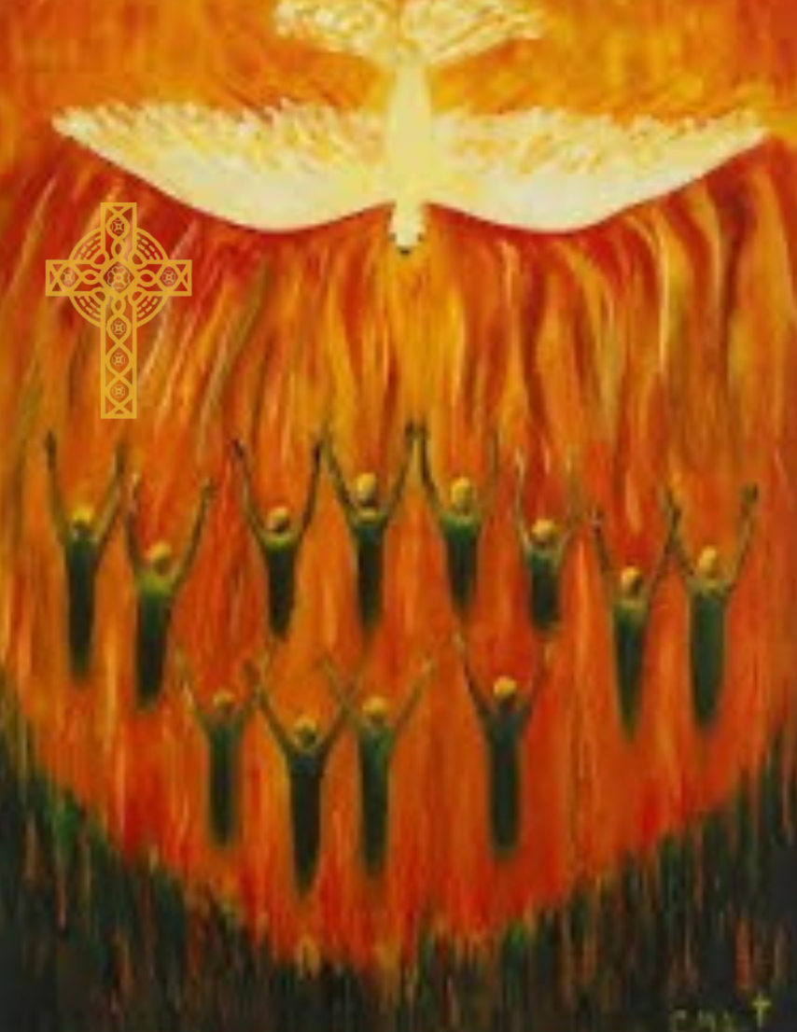
March
1st – Session 21
8th – No Class (Spring Break)
15th – Session 23
22nd – Session 24
29th – No Class
April
5th – No Class
12th – Session 25
19th – Session 26

